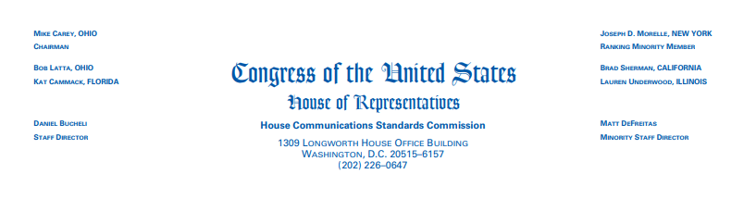

NOTICE OF DISMISSAL

December 19, 2023

TO: Representative Marjorie Taylor Greene

FROM: House Communication Standards Commission
RE: Dismissal of Complaint

On November 19, 2023, the House Communication Standards Commission (HCSC) Received a complaint from Ms. Mary Mccloskey of New Albany, Indiana, alleging that Rep. Taylor Greene violated the following HCSC regulations in the Political and Personal Material paragraph, which are listed on page 2 of the House of Representative Communications Standards Manual:

- Websites and social media content must be related to official representational duties and with all applicable Federal laws and House rules.
- No speculation as to the motivation/intent of individuals.
- Members may not use official communications to provide visual misrepresentations of other individuals, including but not limited to “deep fake” technology.
- Official communications critical of policy may not be personalized or politicized, and may not be used to disparage Members, other individuals, or political parties. For purposes of this tule, “disparage” shall include, but not be limited to, personal insults, ad hominem attacks or attacks on a person’s character.
- No speculation as to motivation/intent of the individual.

On December 8, 2023, the HCSC determined there was no reasonable justification for the complaint.

Accordingly, on December 15, the HCSC, by a recorded vote of 6-0, dismissed the complaint against Rep. Taylor Greene.

