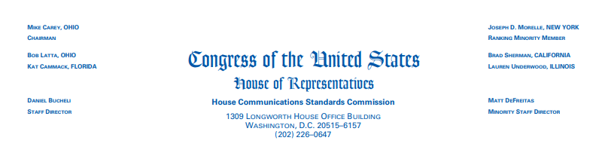

NOTICE OF DISMISSAL

December 19, 2023

TO: Representative Thomas Massie

FROM: House Communication Standards Commission
RE: Dismissal of Complaint

On November 19, 2023, the House Communication Standards Commission (HCSC) Received a complaint from Ms. Mary Mccloskey of New Albany, Indiana, alleging that Rep. Massie violated the following HCSC regulations in the Political and Personal Material paragraph, which are listed on page 2 of the House of Representative Communications Standards Manual:

- No speculation as to the motivation/intent of individuals.
- Members may not use official communications to provide visual misrepresentations of other individuals, including but not limited to “deep fake” technology.

On December 8, 2023, the HCSC determined there was no reasonable justification for the complaint.

Accordingly, on December 15, the HCSC, by a recorded vote of 6-0, dismissed the complaint against Rep. Massie.

